Civil war in Somalia

UNSC Resolution: | 733
Date of adoption: | 23-Jan-1992
Operative paragraph: | 7
Demand number: | 733,0711

Sarah-Myriam Martin-Brûlé

Wording of demand
- cooperate with the Secretary-General to this end and facilitate the delivery by the United Nations, its specialized agencies and other humanitarian organizations of humanitarian assistance to all those in need of it, under the supervision of the coordinator

List of addressees of the demand
- Government of Somalia, United Somali Congress Faction

Short-term compliance

Description of the addressee(s)’ conduct

“Agreements with Ali Mahdi an Aideed on access and other issues were often broken within hours-if not at their orders, at least with their acquiescence.
Hirsh, John L. and Robert B. Oakley. 1995. Somalia and Operation Restore Hope: Reflections on Peacemaking and Peacekeeping. USIP. P.21

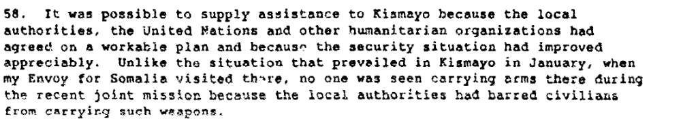

Report of the Secretary General on the Situation in Somalia, 11 March 1992 S/23693, p.13.

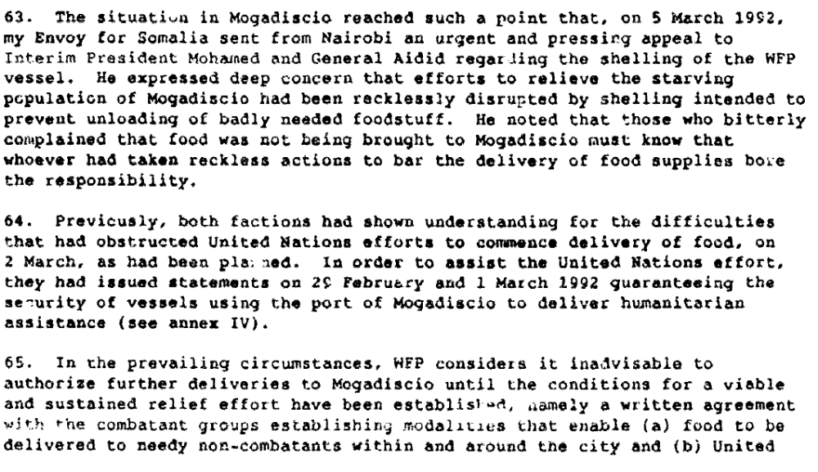
Report of the Secretary General on the Situation in Somalia, 11 March 1992 S/23693, p.14.
http://daccessdds.un.org/doc/UNDOC/GEN/N92/109/47/PDF/N9210947.pdf?OpenElement

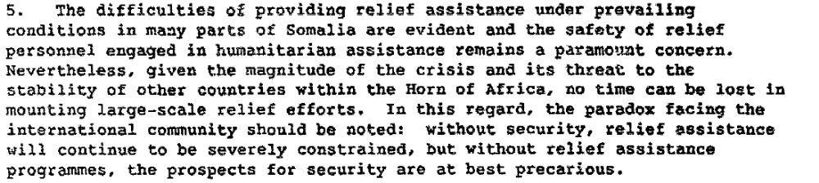

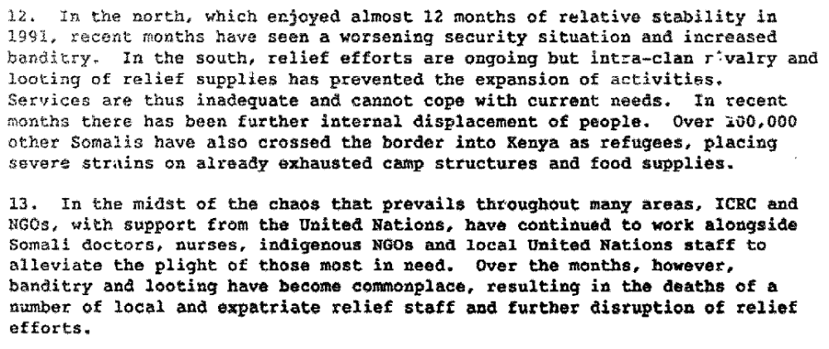

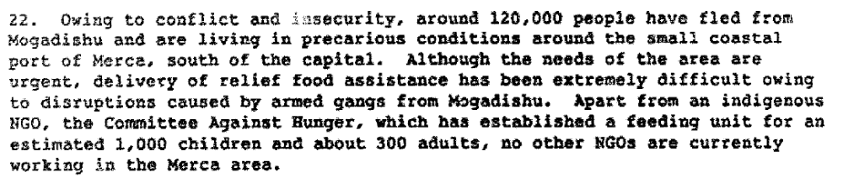

Report of the Secretary General on the Situation in Somalia, 21 April 1992 S/23829/Add.1.

“On 11 March 1992, pursuant to resolution 733 (1992), the Secretary-General submitted to the Council a report on the situation in Somalia, dealing in particular with the efforts to secure a cessation of hostilities to permit the humanitarian assistance to be distributed, to promote a ceasefire, and to assist in the process of a political settlement of the conflict in Somalia. He reported that heavy fighting had persisted in Mogadishu since November 1991. The fighting had resulted in widespread death and destruction, forced hundreds of thousands of civilians to flee the city, caused dire need for emergency humanitarian assistance, and brought about a grave threat of widespread famine. It had also seriously impeded United Nations efforts to deliver much-needed humanitarian assistance to the affected population in and around Mogadishu. (...)He observed that because of the intolerable security situation, it had not been possible to provide food supplies to Mogadishu since December 1991.”

Repertoire of the Practice of the Security Council, p. 312.
http://www.un.org/Depts/dpa/repertoire/8992/CHAPTER%208/AFRICA/item%2006_Somalia_.pdf

Assessment

Short-term compliance
X No or marginal compliance (1) | Medium low compliance (2) | Medium high compliance (3) | Full or almost full compliance (4)

Considerations underlying the assessment

Considering the reckless nature of attacks on humanitarian organizations and on the UN personnel, there were a clear lack of cooperation on the part of the Government of Somalia and the United Somali Congress Faction and thus, no or marginal compliance with the demand.

Medium-term compliance

Description of the addressee(s)’ conduct

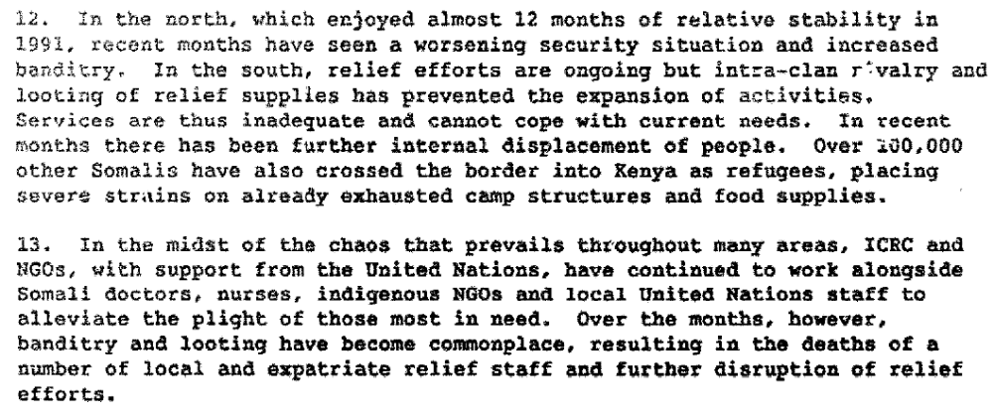

Report of the Secretary General on the Situation in Somalia, 21 April 1992 S/23829/Add.1.

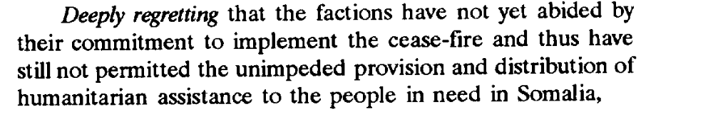

UNSC Resolution 746, 17. March 1992.
http://www2.un.int/Countries/Somalia/1121968696.pdf

“Through July and August the situation deteriorated further and the international community began to take notice. Prompted by the United Nations, relief supplies and logistical support were provided by member countries, and in August 1992 Operation Provide Relief was authorized by U.S. President George Bush.(...) . However, the lack of both a central authority and agreement between the rival factions made delivery of humanitarian relief difficult. On August 16, 1992, one Somali faction stole the first relief supplies in the southern town of Kismayo where many thousands were on the brink of starvation. Raids on relief supplies continued throughout Somalia. (...) The Somali factions became increasingly resistant to UN requests for security forces to protect humanitarian supplies and workers. By the end of October 1992, General Aideed, now the most powerful man in Mogadishu, objected to the deployment of the first UNOSOM troops, demanded they be removed, and expelled a UN official. By the end of November, when the flow of relief supplies to the starving was further slowed by factional fighting, the United Nations began to consider changing its mission objectives.” P. 81.

“On March 27, 1993, the United Nations allocated $142 million for relief and rehabilitation efforts in addition to peacekeeping expenses. These steps, however, did not resolve the crisis. Previous cease-fire agreements were ignored, and UN forces and relief workers were threatened. On June 5, 1993, a Pakistani force of UN peacekeepers was ambushed by Aideed loyalists. Twenty-four Pakistani troops were killed. UN efforts to punish those responsible were unsuccessful. Operationally, UNOSOM II was experiencing severe problems in achieving its mission.” P.82

Blakley, Mike. 1999. “Somalia”. The Cost of Conflict: Prevention and Cure in the Global Arena. Brown & Rosecrance, eds. Carnegie Commission on Preventive Deadly Conflicts.
http://www.wilsoncenter.org/subsites/ccpdc/pubs/costs/chap04.pdf

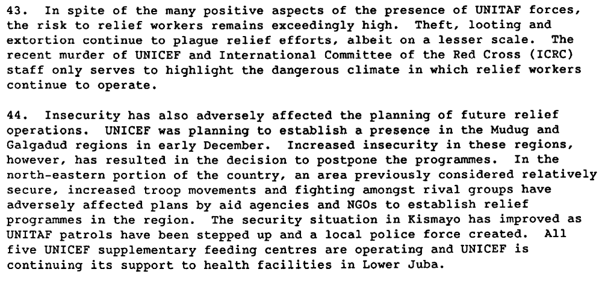

Report of the Secretary General on the Situation on Somalia. S\25168, 26 January 1993.

Assessment

Medium-term compliance
X No or marginal compliance (1) | Medium low compliance (2) | Medium high compliance (3) | Full or almost full compliance (4)

Considerations underlying the assessment
From 1992 to 1995, there were continuous obstruction of the UN and UN related humanitarian assistance operations.

Depth of demand

Assessment

Level of depth of demand
Low depth of demand (1) | X Medium depth of demand (2) | High depth of demand (3)

Considerations underlying the assessment
Survival of each party was not directly at risk, however, food looting and banditry allowed for each party to gain control and power over the population. Humanitarians became a source of economic extraction. Moreover, social control over the population was also a key strategic objective to gain further power. In such case, violence, coercion of the population became one of the main tactical weapon for each faction (and not only a by-product of military activity).

Level of confidence about coding decisions

Level of confidence about coding decision
Extremely high | X High | Moderate

Comments to IPI (if any)

